Azure Containers

1. Prepare a directory

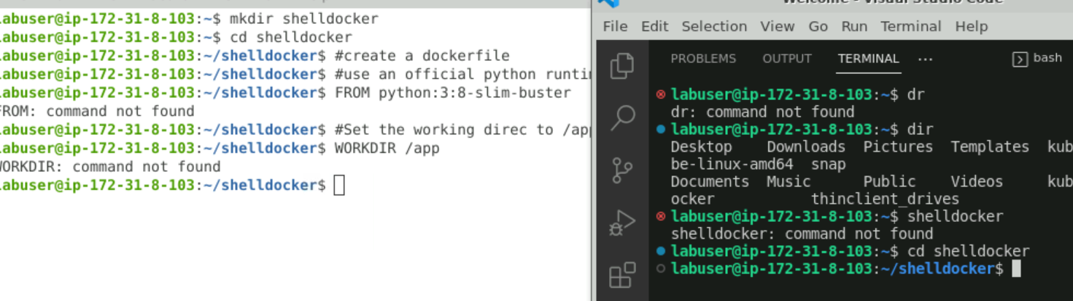

1. Create dockerfile

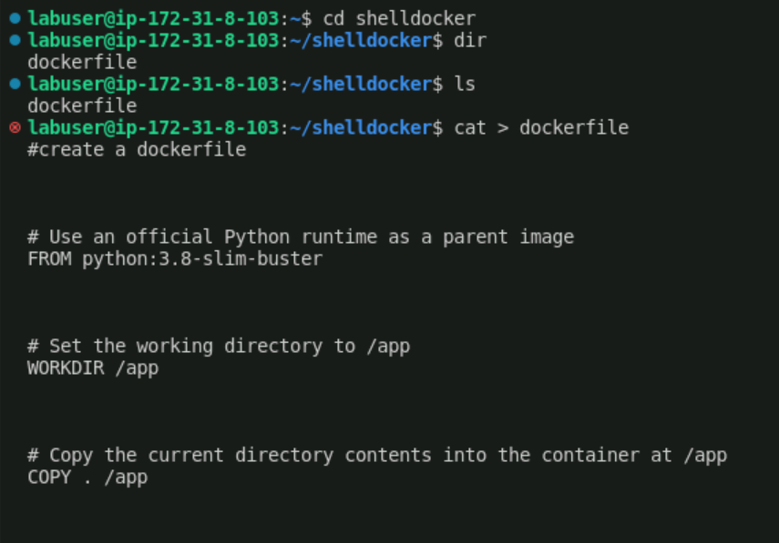

[12:02 PM] Vaid, Kriti SBOBNG-PTIY/TCE

#create a dockerfile

# Use an official Python runtime as a parent image  
FROM python:3.8-slim-buster

# Set the working directory to /app  
WORKDIR /app

# Copy the current directory contents into the container at /app  
COPY . /app

# Install any needed packages specified in requirements.txt  
RUN pip install -r requirements.txt

# Make port 80 available to the world outside this container  
EXPOSE 80

# Define environment variable  
ENV NAME World

# Run app.py when the container launches  
CMD ["python", "app.py"]

* Ctrl+z to save

Ls to review

Cat > app.py

Cat>requirements.txt

Create app by cat > app

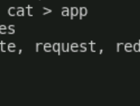

# Import necessary modules and libraries  
from flask import Flask, render_template, request, redirect, url_for

# Create an instance of the Flask web application  
app = Flask(_name_)

# Define routes and views  
@app.route('/')  
def index():  
    return 'Hello, World!'

# Example route with dynamic content  
@app.route('/user/<username>')  
def show_user_profile(username):  
    return f'User {username}'

# Example route that handles form submissions  
@app.route('/submit', methods=['GET', 'POST'])  
def submit_form():  
    if request.method == 'POST':  
        data = request.form['data']  
        # Process the submitted data here  
        return f'You submitted: {data}'  
    return render_template('form.html')

# Run the application if this file is executed  
if _name_ == '_main_':  
    app.run(debug=True)

app.run(host='0.0.0.0', port=9002)

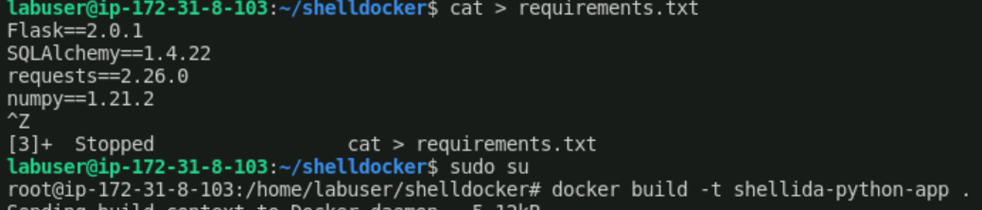

1. DEPLOY AZURE CONTAINER INSTANCES

[Tutorial - Prepare container image for deployment - Azure Container Instances | Microsoft Learn](https://learn.microsoft.com/en-us/azure/container-instances/container-instances-tutorial-prepare-app)



[Tutorial - Prepare container registry to deploy image - Azure Container Instances | Microsoft Learn](https://learn.microsoft.com/en-us/azure/container-instances/container-instances-tutorial-prepare-acr)

1. [Kubernetes on Azure tutorial - Prepare an application - Azure Kubernetes Service | Microsoft Learn](https://learn.microsoft.com/en-us/azure/aks/tutorial-kubernetes-prepare-app)